Iu

|  |  |  |  |  |  |  |
| --- | --- | --- | --- | --- | --- | --- |
| Address | Price/year | Elementary | Middle | High | Bed/bath | Area |
| 5968 Elk Forest Ct, Elkridge | 364900/1975  <https://www.zillow.com/homedetails/5968-Elk-Forest-Ct-Elkridge-MD-21075/36985357_zpid/> | Elkridge 6 | Elkridge landing 8 | Howard 8 | 4/2 No HOA | 2238 |
| 5743 Yellowrose Ct, Columbia, MD 21045 | 300k /1974  <https://www.zillow.com/homedetails/5743-Yellowrose-Ct-Columbia-MD-21045/37006008_zpid/> | Phelps Luck 4 | Bonnie Branch 7 | Howard 8 | 3/3 $56 | 1720 |
| 6241 Hanover Rd, Hanover, MD 21076 | 400k/1930  <https://www.zillow.com/homedetails/6241-Hanover-Rd-Hanover-MD-21076/36985969_zpid/?> | Elkridge 6 | Elkridge landing 8 | Howard 8 | 5/3 No HOA | 3328 one floor |
| 8547 Harvest View Ct, Ellicott city | 370k/1991  <https://www.zillow.com/homedetails/8547-Harvest-View-Ct-Ellicott-City-MD-21043/37028212_zpid/> | Waterloo  7 | Ellicott Mills 9 | Centennial 9 | 4/2F/2H $27 | 1860 |
| 9918 Carrigan Dr, Ellicott City, MD 21042 | 425/1959  <https://www.realtor.com/realestateandhomes-detail/9918-Carrigan-Dr_Ellicott-City_MD_21042_M63220-98156?view=qv> | Centennial Lane 9 | Burleigh Manor 8 | Centennial 9 | 3/2  Single home | 1537/ one floor |
| 8844 papillon drive |  | Veterans | Ellicottt city | centennial |  |  |
|  |  |  |  |  |  |  |

I will make a note of you interest on that specific requisition. Pls apply and email me when you have submitted your application. [Francisco.medrano@fmc-na.com](mailto:Francisco.medrano@fmc-na.com).

Brad in US waters

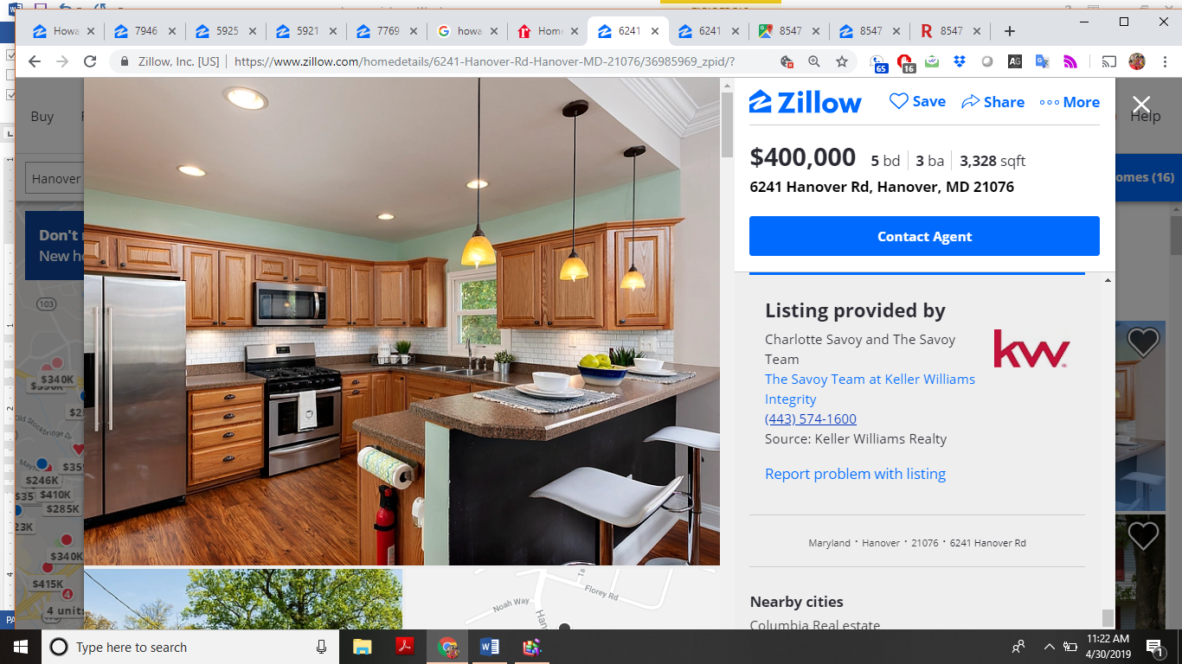

<https://www.realtor.com/realestateandhomes-search/Ellicott-City_MD/schools/Howard-High-School-0734297031/price-na-450000>